**Relationships in Hibernate**

* In DB we can have following types relationships

1. One – to – One
2. One – to – Many
3. Many – to – One
4. Many – to – Many

**One-to-One**

* Let’s take an example of a car and its engine. Every car has an engine, and each engine belongs to one car. In simple words, this statement translates to “one” car has “one” engine. So, here the relationship between car and the engine is one-to-one.
* Each record in one table is related to exactly one record in the second table and vice versa.
* One – to – One relationship occurs when one record in “Primary Table” corresponds to exactly one record in the “Relationship Table”
* We can achieve One – to – One relationship between tables by having common column in “Primary Table” & “Relationship Table” having that column as Primary Key in both tables as shown below

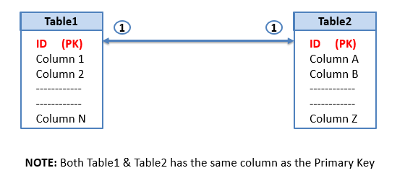

* In Hibernate we achieve One – to – One relationship with the help of **<one-to-one>**tag in the mapping file of the Java Bean which corresponds to the Primary Table.

**<one-to-one name=*"propertyNM"***

**class=*"pkgNM.RelatedBeanName"***

**cascade=*"all" /*>**

* If We are Using Annotation, the @OneToOne annotation is used to create the one-to-one relationship.
* Cascade attribute present in **<one-to-one>**tag transforms the operation done on the Primary Object to its Related Objects. This attribute has various values,

1. **cascade=*"none"***(its default) It tells the Hibernate to ignore the relationship. i.e. None of the operation are carried to Related Objects
2. **cascade=*"all"***All the operations like Save, Update, Delete on Parent Object will be carried to its Related Objects
3. **cascade=*"save"***Only Save operation on Parent Object will be carried to its Related Objects
4. **cascade=*"update"***Only Update operation on Parent Object will be carried to its Related Objects
5. **cascade=*"delete"***Only Delete operation on Parent Object will be carried to its Related Objects
6. **cascade=*"save-update"***Only Save & Update operation on Parent Object will be carried to its Related Objects
7. Many More (there are other 2)